Name – Davender Singh

Student ID – ***********

Course – CCP555NSA

Professor – David Humphrey

**GitHub repo links:**

**Fragments:** <https://github.com/davender-singh1/fragments>

Screenshot of CI workflow failing ESLint:

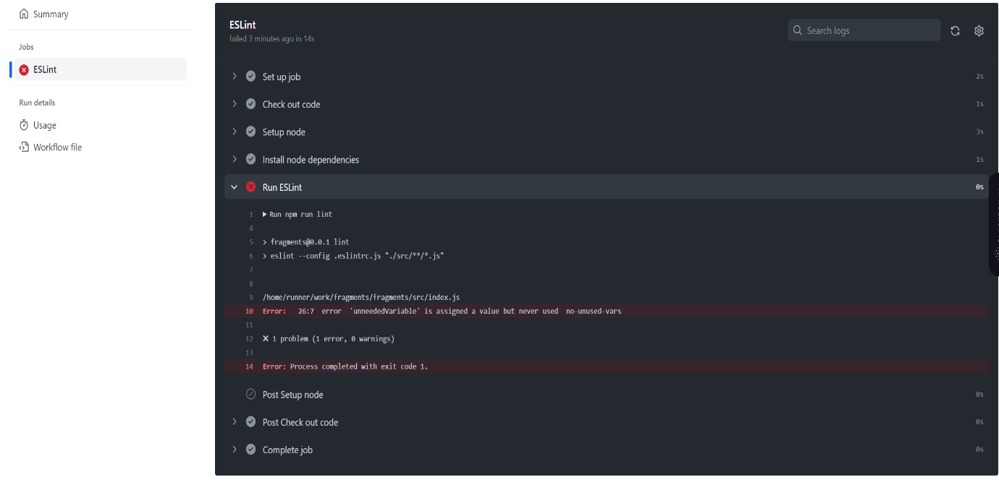

Screenshot of CI workflow failing one or more Unit Tests:  
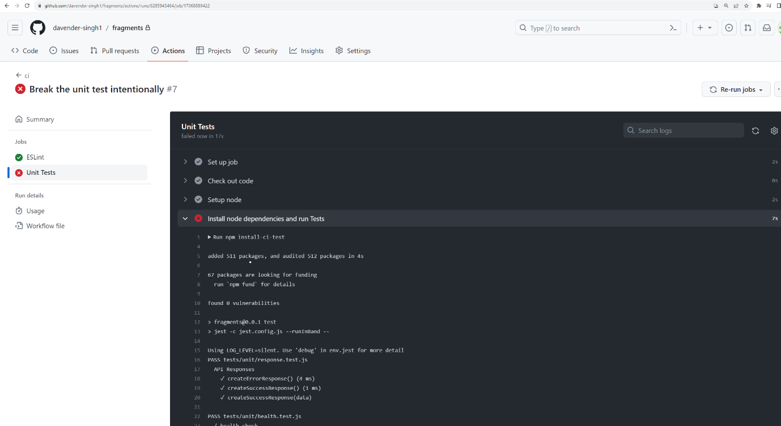

Screenshot of CI workflow passing ESLint:  
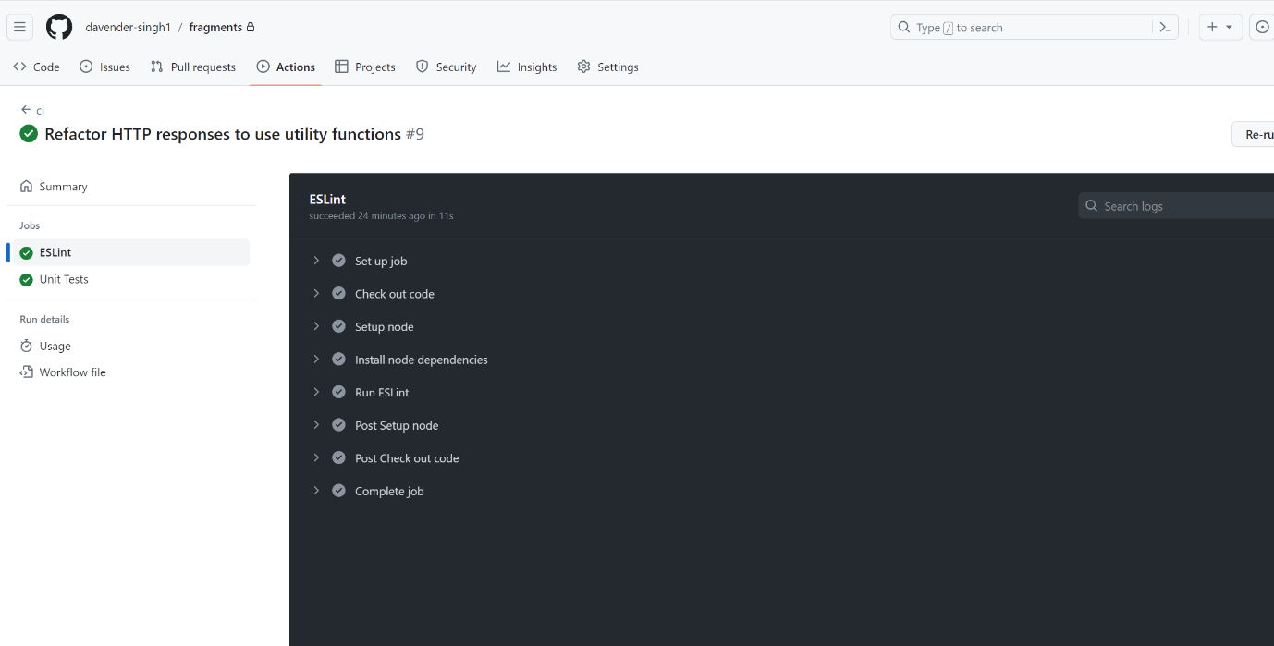

Screenshot of CI workflow passing all Unit tests:

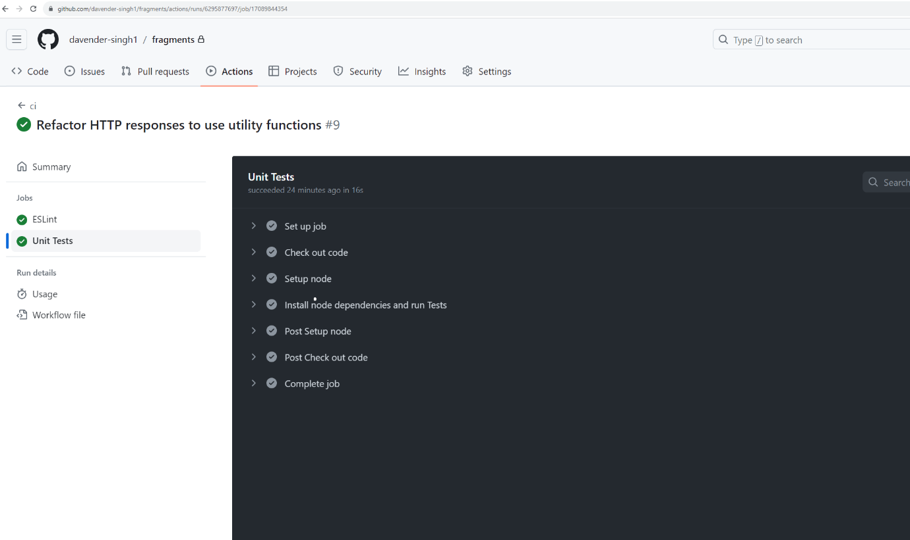

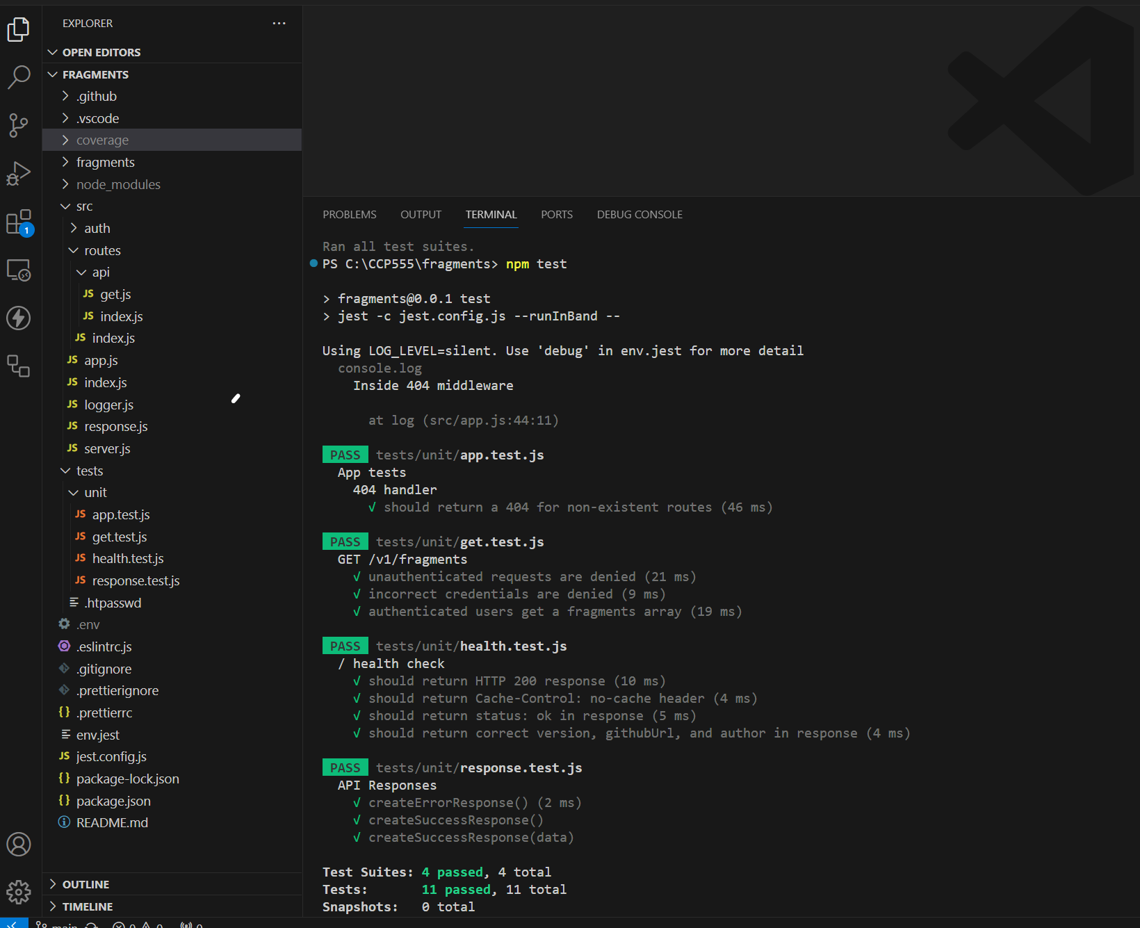

Screenshot of the test coverage report, showing the app.js 404 handler being covered. Open the file coverage/lcov-report/src/app.js.html in your browser to show the lines of code being hit (green) by the tests, and those being missed (red):  
